

Rosanna Cubs & Scouts
– Swimming night
WaterMarc Greensborough
Tuesday 10th March, 6:30pm-8:30pm

This week, we’ll be going swimming (and sliding) at WaterMarc in Greensborough. This will be a fun night rather than a badge night – Cubs will have a swimming night later in the year for Swimming Badges.

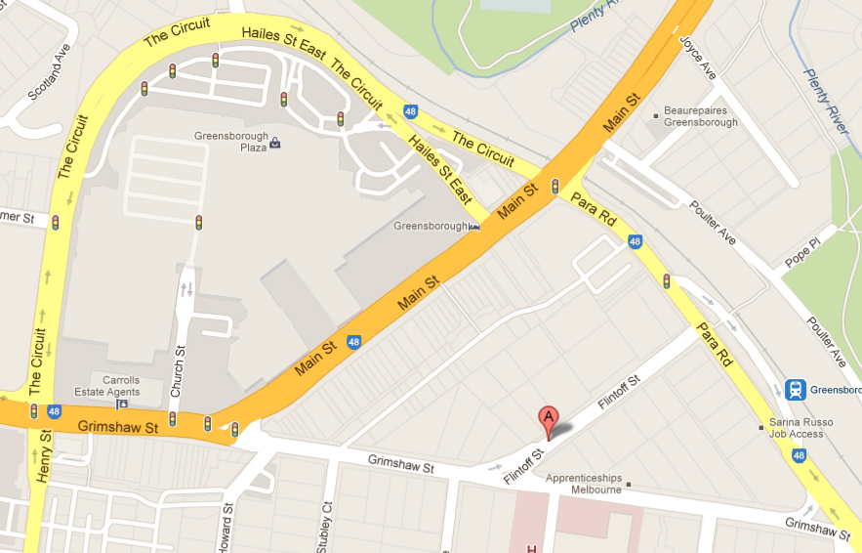
- Time: 6:30-8:30pm – Note different time
to normal Cubs and Scouts
- Cost: $11.50 per Cub/Scout
Parents not required to attend, but
if doing so and NOT swimming, a
fee of $3.00 still applies. Refer
www.watermarcbanyule.com.au
- Location: WaterMarc Aquatic Centre –
1 Flintoff St, Greensborough
- Bring: Togs, Towel, warm clothes to go
home in

Don’t miss out – see you there!

Regards

The Leaders
Rosanna Cub Scouts and Scouts

See Rosanna Cubs at http://www.rosannacubs.org

